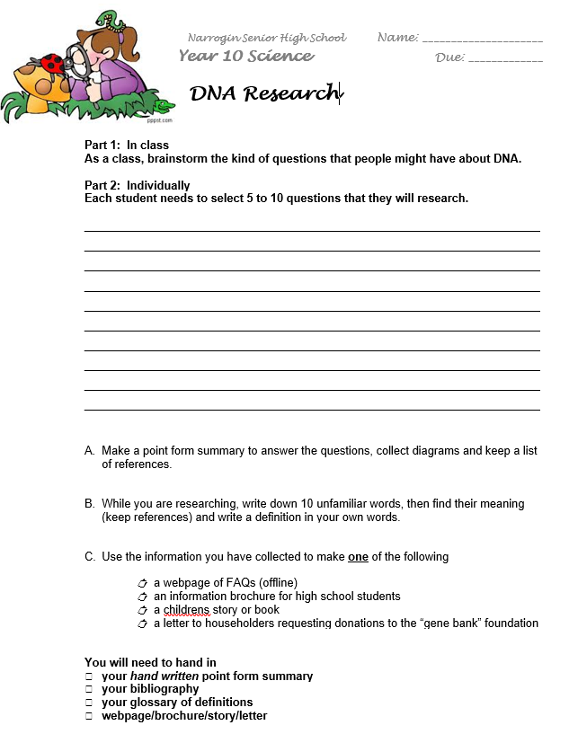
Glossary of Unfamiliar Words:

- ___________________________
Meaning: ________________________________________________________________ ___________________________________________________________________________
- ___________________________
Meaning: _______________________________________________________________ ___________________________________________________________________________
- ___________________________
Meaning: _______________________________________________________________ ___________________________________________________________________________
- ___________________________
Meaning: _______________________________________________________________ ___________________________________________________________________________
- ___________________________
Meaning: _______________________________________________________________ ___________________________________________________________________________
- ___________________________
Meaning: _______________________________________________________________ ___________________________________________________________________________

- ___________________________
Meaning: ________________________________________________________________ ___________________________________________________________________________
- ___________________________
Meaning: _______________________________________________________________ ___________________________________________________________________________
- ___________________________
Meaning: _________________________________________________________________ ___________________________________________________________________________
- ___________________________
Meaning: ________________________________________________________________ ___________________________________________________________________________

Write down dot point information on each of your questions:
- __________________________________________________________________________________________________________________________________________________________________________________________________________________________________________________________________________________________________________________________________________________________________________________________________________________________________________________________________
- __________________________________________________________________________________________________________________________________________________________________________________________________________________________________________________________________________________________________________________________________________________________________________________________________________________________________________________________________
- __________________________________________________________________________________________________________________________________________________________________________________________________________________________________________________________________________________________________________________________________________________________________________________________________________________________________________________________________
- __________________________________________________________________________________________________________________________________________________________________________________________________________________________________________________________________________________________________________________________________________________________________________________________________________________________________________________________________
- _______________________________________________________________________________________________________________________________________________________________________________________________________________________________________________________________________________________________________________________________________________________________________________________
- __________________________________________________________________________________________________________________________________________________________________________________________________________________________________________________________________________________________________________________________________________________________________________________________________________________________________________________________________
- __________________________________________________________________________________________________________________________________________________________________________________________________________________________________________________________________________________________________________________________________________________________________________________________________________________________________________________________________
- __________________________________________________________________________________________________________________________________________________________________________________________________________________________________________________________________________________________________________________________________________________________________________________________________________________________________________________________________
- __________________________________________________________________________________________________________________________________________________________________________________________________________________________________________________________________________________________________________________________________________________________________________________________________________________________________________________________________
- __________________________________________________________________________________________________________________________________________________________________________________________________________________________________________________________________________________________________________________________________________________________________________________________________________________________________________________________________
Marking guide /25

 | 1 | 2 | 3 | 4 | 5
Research and notes | Less than 5 answers | 5 short answers only | 1-2 detailed and 4-5 short answer | 3-4detailed and 2-3 short answer | 5 detailed or 10 short answer questions (or mix of both)
Research and notes | Cut and paste, whole sections or irrelevant information | Cut and paste, whole sentences copied | Point form but not hand written | Hand written but whole sentences or poorly organised | Hand written, point form, all information included and organised
Bibliography | 2 or less references; incorrect format | 3 or more references; correct format
Glossary | Less than 5 words | 5-9 words; out of context or not in own words | 10 words, defined in context and in own words
Web FAQ/Brochure/Book or Letter | Inappropriate text and layout conventions; Language unsuitable for target audience | Uses suitable text and layout convention; suitable for target audience
Web FAQ/Brochure/Book or Letter | One or two diagrams only | 3 or more diagrams
Web FAQ/Brochure/Book or Letter | Cluttered, unclear or hard to read; incomplete | Visually appealing but lacking in content or clarity; too much or too little text or graphics | Visually appealing, good use of text and graphics | Visually appealing, good use of graphics, text, captions and font/colour
Web FAQ/Brochure/Book or Letter | Some spelling or grammar mistakes | No spelling or grammar mistakes

